**National University of Computer & Emerging Sciences (NUCES) Islamabad,**

Department of Computer Science

**Programming Fundamentals – Spring 2022**

**LAB 09**



**Learning Outcomes**

In this lab you are expected to learn the following:

* Loops (for, do-while)
* Nested Loops

**Loops**

In computer programming, loops are used to repeat a block of code. For example, let's say we want to show a message 100 times. Then instead of writing the print statement 100 times, we can use a loop. That was just a simple example; we can achieve much more efficiency and sophistication in our programs by making effective use of loops.

There are 3 types of loops in C++.

* for loop
* while loop
* do...while loop

**for Loop**

The syntax of for-loop is

for (initialization; condition; update) {

// body of-loop

}

Here :

* Initialization - initializes variables and is executed only once
* condition - if true, the body of for loop is executed
* if false, the for loop is terminated
* update - updates the value of initialized variables and again checks the condition

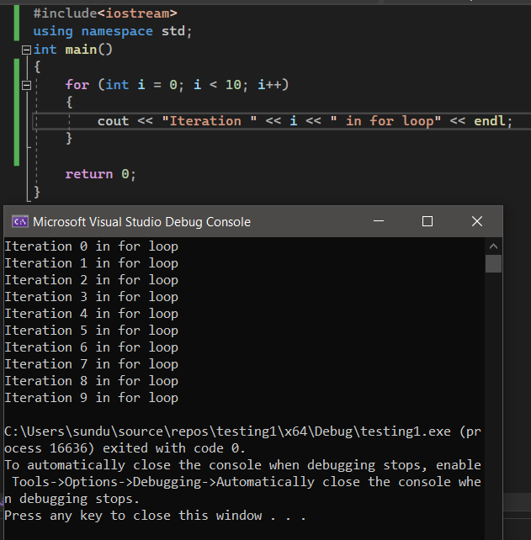

**Do…While Loop**

The do/while loop is a variant of the while loop. This loop will execute the code block once, before checking if the condition is true, then it will repeat the loop as long as the condition is true.

Syntax:

do

{ // body of loop

} while(condition);

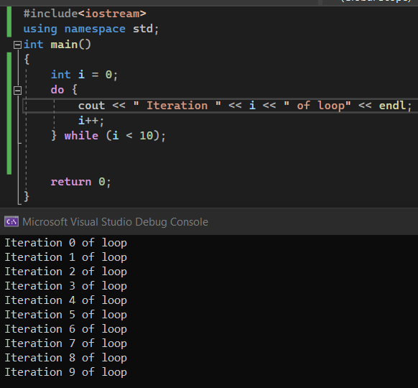

**Nested loop:**

A loop within another loop is called a nested loop.

An example of nested for-loop is given in the image below:

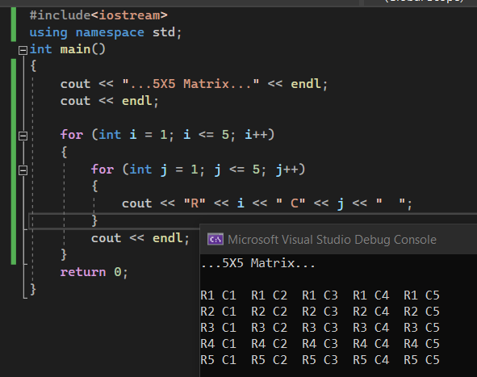

The exact same output can be displayed using nested do while loop as well;

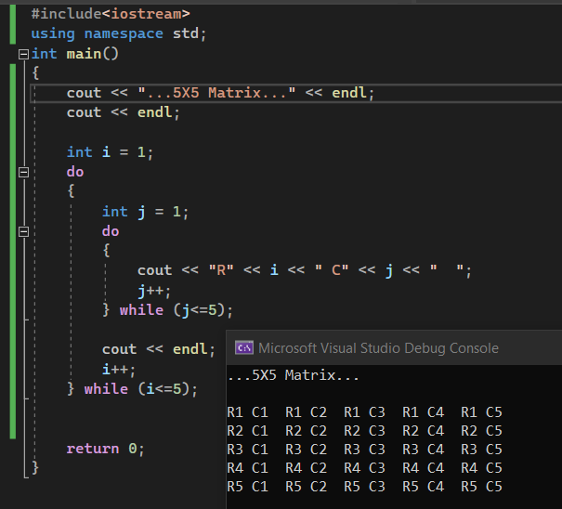

Different patterns can be printed using nested loops as well, like the one shown in the image below.

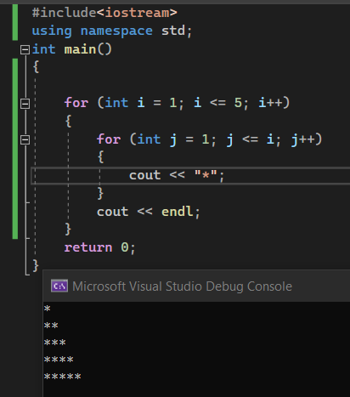

**Practice Tasks:**

**Task 1:**

Write a program that displays the following shape using **nested for loop**. Don’t hard code the values. Ask user to input the number of lines that shape must cover, so that by changing a single variable the size of the whole shape changes

For example:

For n=13 , n=11 , n=9 , n=7 , n=5

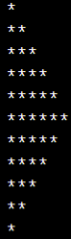 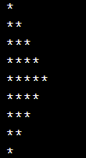

**Task 2:**

Modify the code in task 1 to make the following shape. Don’t hard code the values. Ask user to input the number of lines that shape must cover, so that by changing a single variable the size of the whole shape changes

For n=13 , n=11 , n=9 , n=7

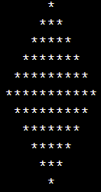

**Task 3:**

Write a program in C++ to find the Greatest Common Divisor (GCD) of two numbers using **while loop.**

Sample Output:

Input the first number: 25

Input the second number: 15

The Greatest Common Divisor is: 5

**Task 4:**

Let’s assume you create a system which asks the user for the number of students and the number of test scores per student. A nested inner loop, should ask for all the test scores for one student, iterating once for each test score. The outer loop should iterate once for each student and take student name as input. After taking input for 3 test scores, calculate average for each student. Take 3 test scores and 4 students.

*Note: use do-while loops*

**Task 5:**

Write a program in C++ to find the sum of the series 1 + 1/2^2 + 1/3^3 + ..+ 1/n^n.

**Sample Output:**

Input the value for nth term: 5

1/1^1 = 1

1/2^2 = 0.25

1/3^3 = 0.037037

1/4^4 = 0.00390625

1/5^5 = 0.00032

The sum of the above series is: 1.29126